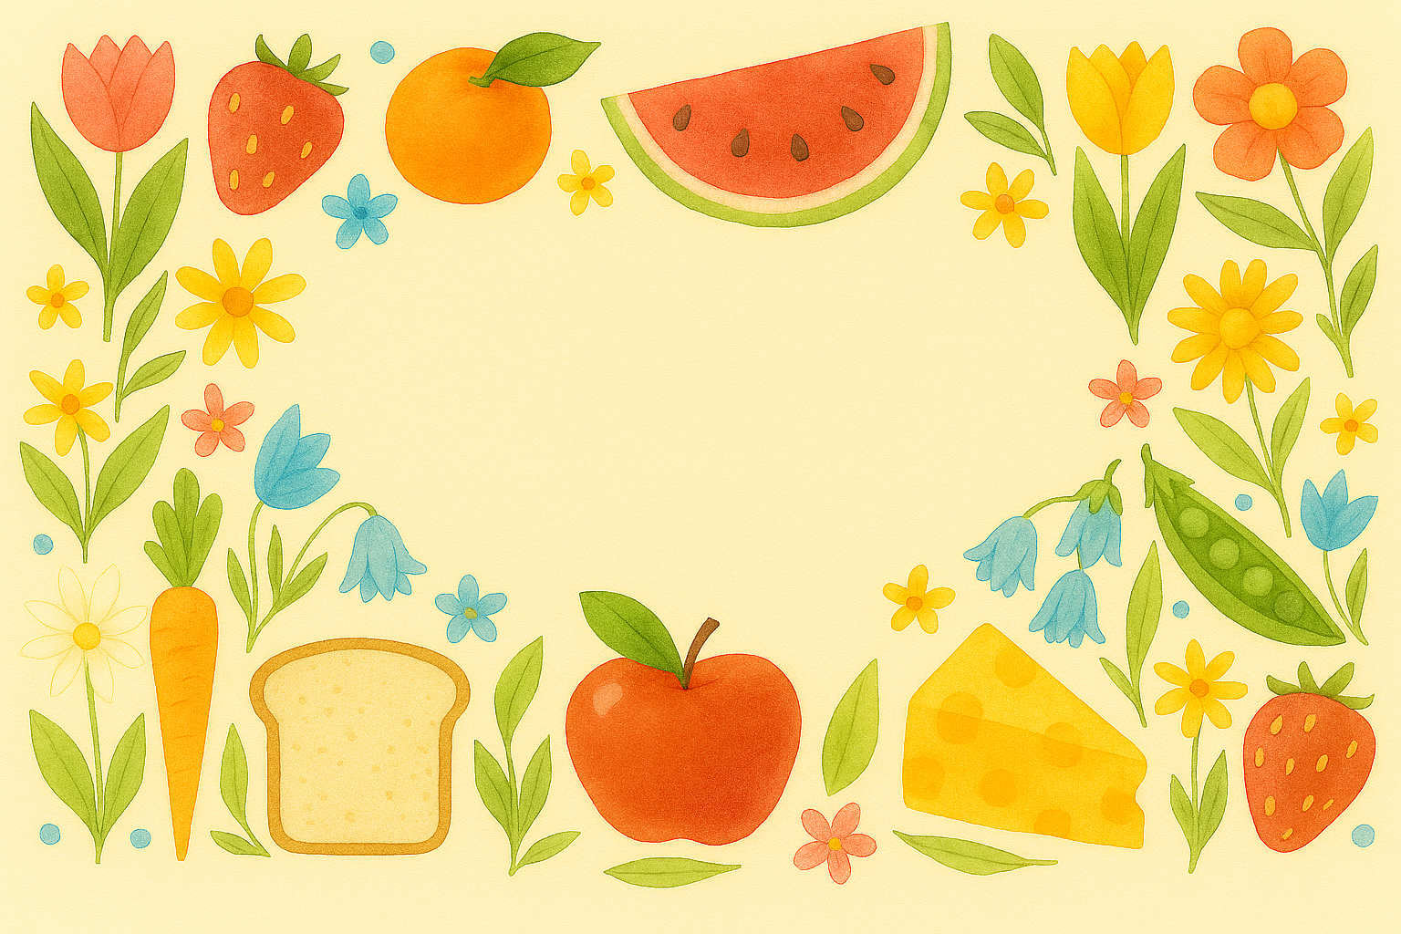
10/25/2026 - 10/31/2026
 | Sunday | Monday | Tuesday |  | Wednesday | Thursday |  | Friday | Saturday
Breakfast | Assorted Bread & Fruit  Oatmeal  Scrambled Eggs | Assorted Bread & Fruit  Oatmeal  Eggs to Order  Cream Chipped Beef | Assorted Bread & Fruit  Oatmeal  Scrambled Eggs  Blueberry Pancakes  Breakfast Sausage |  | Assorted Bread & Fruit  Apple Cinnamon Baked Oatmeal  Scrambled Eggs  Breakfast Potatoes | Assorted Bread & Fruit  Oatmeal  Scrambled Eggs  Cinnamon French Toast  Bacon |  | Assorted Bread & Fruit  Oatmeal  Eggs to Order  Sausage Patty | Assorted Bread & Fruit  Oatmeal  Scrambled Eggs  Sausage Gravy & Biscuit
Featured Lunch | Appetizer  Ambrosia Salad  Entrée  Roast Beef w/Gravy❤  Tilapia w/Garlic Lemon Herb Sauce  Oriental Shrimp Salad❤  Ham & Swiss Sandwich  Sides  Loaded Mashed Potatoes  Parslied Carrots  Steamed Broccoli  Lemon Meringue Pie | Appetizer  Garden Vegetable Soup  Tossed Salad  Entrée  Alabama White Pulled Pork Sandwich  Chicken Salad Platter❤  Turkey Chef Salad  Herb Roasted Pork  Sides  Baked Beans  Green Beans | Appetizer  Cream of Tomato Soup  Tossed Salad  Entrée  Grilled Cheese  Turkey & Provolone Sandwich  Salmon Salad❤  Herb Baked Chicken❤  Sides  Onion Rings  Buttered Carrots |  | Appetizer  Beef Rice Soup  Tossed Salad  Entrée  Reuben Sandwich  Seafood Salad on Croissant❤  Harvest Chicken Salad❤  Herb Baked Chicken❤  Sides  Potato Salad  Green Peas | Appetizer  Italian Wedding Soup  Tossed Salad  Entrée  Monte Cristo Sandwich  Hot Dog  Balsamic Chicken Salad❤  Herb Baked Fish❤  Sides  Homefried Potatoes  Steamed Cauliflower |  | Appetizer  Chicken Noodle Soup  Tossed Salad  Entrée  Fried Fish Sandwich  Ham & Swiss Sandwich  BLT Salad  Breaded Haddock Square  Sides  Macaroni Salad  Roasted Squash Blend | Appetizer  New England Clam Chowder  Tossed Salad  Entrée  Steak Quesadilla❤  Egg Salad Sandwich❤  Chicken Caesar Salad  Herb Baked Chicken❤  Sides  Guacamole  Buttered Corn
Featured Dinner | Appetizer  Bacon Corn Chowder  Tossed Salad  Entrée  Chicken Tenders  Ham & Swiss Sandwich  Oriental Shrimp Salad❤  Herb Baked Chicken❤  Sides  Tater Tots  Steamed Broccoli | Appetizer  Asian Cole Slaw  Garden Vegetable Soup  Entrée  Asian Pepper Steak over Rice  Cheese Manicotti w/Spinach Alfredo  Turkey Chef Salad  Chicken Salad Platter❤  Sides  White Rice  Oriental Vegetable Blend  Green Beans  Angel Food Cake | Appetizer  Pear Salad  Cream of Tomato Soup  Entrée  Homemade Lasagna  Chicken Marsala❤  Salmon Salad❤  Turkey & Provolone Sandwich  Sides  White Rice  Roasted Brussels Sprouts  Buttered Carrots  Frosted Spice Cake |  | Appetizer  Creamy Fruited Jello  Beef Rice Soup  Entrée  Pork & Sauerkraut❤  Baked Haddock in Lemon Butter❤  Harvest Chicken Salad❤  Seafood Salad on Croissant❤  Sides  Vegetable Medley  Green Peas  Peanut Butter Pie | Appetizer  Fresh Pineapple  Italian Wedding Soup  Entrée  Bacon Cheeseburger  Bourbon Glazed Chicken Thigh  Balsamic Chicken Salad❤  Hot Dog  Sides  Sidewinder Fries  1/0  Steamed Cauliflower  Chocolate Chip Cookie Pie |  | Appetizer  Cranberry Orange Relish  Chicken Noodle Soup  Entrée  Sliced Roast Turkey Breast w/Gravy❤  Glazed Ham Loaf  BLT Salad  Ham & Swiss Sandwich  Sides  Bread Stuffing  Succotash  Roasted Squash Blend  Shoo Fly Pie | Appetizer  Roasted Root Vegetable Salad  New England Clam Chowder  Entrée  Polish Kielbasa w/Peppers & Onions  Garlic Butter Shrimp❤  Chicken Caesar Salad  Egg Salad Sandwich❤  Sides  Haluski  Buttered Corn  Fruits of the Forest Pie
Tossed Side Salad, Mashed Potato or Mashed Sweet Potato (Check Menu Jacket for Availability), Potato Chips, Pretzels, Pickles, and Carrot Sticks are always available to accompany any lunch or entrée. |  |  |  | Heart-healthy choices help to reduce the amount of sodium in your diet |  |  | We hope you enjoy all your meals with us. For any questions about the menu or your meals please see any member of dining services.

week two
Fall/Winter Menu

